ABSTRACT

Emotions are an integral part of human interactions and are significant factors in determin-ing user satisfaction or customer opinion. Most natural form of human communication depends on speech. In order to understand human speech by enabling machines, computers can act as an intermediate for human experts, so that it can respond accurately and reliably to human voices. This can be achieved by a speech recognition system, which permits a data processor to identify the words a person speaks in a microphone or telephone, and convert them into written text. Speech Recognition (SR) and its application is the thrust area in research during the past three decades which is carried out on various aspects, especially in the field of Information and Communication Technology (ICT) for speeding up scientific advancements. Also, people interact with systems to utilize the technology in greater amounts without the acquaintance of operating computer keyboards. At present, Automatic Speech Recognition (ASR) is effectively utilized for communication between humans and machines. This paper analyzes the accuracy of feature extraction based on modeling which is implemented using MFCC and HMM for two different types of connected and continuous speech. The recognition result shows that the overall system accuracy for connected words is 79.22 % and continuous word is 50%.
.

- INTRODUCTION
1.1 Objective of the Project:
The main objective of this software is to recognize the emotion behind any sound. Today we have many technologies that provide the functionality of communicating with machines in human's Natural form, speech. Though, the traditional Means of Communicating with a machine or computers, such as switches, keyboards, etc., is still in dominance due to the complexities that come with implementing a successful speech recognition system with a broad range of functionalities. Having to recognize speech successfully is one part of the problem, the other part of the problem is being able to do Anything using what is said. There aren't many systems that implement a speech Recognition system with the flexibility a mouse or a keyboard has when interacting with a computer, that is, what we can do using our voice alone tends to be somewhat limited.
To further elaborate, say a system is designed to simply type what is being said, which can Be done using the existing API's available. If The user wants to be able to use this for another purpose such as to give commands to the computer, adapting such a system to suit the later need, it would be a tedious task. If the user is even more ambitious and wants to automate functions around the house, such as switch on lights or other appliances, the adoption process becomes even more complex.

1.2 Main Purpose:
Emotion detection has become one of the biggest marketing strategies, in emotion detection the mood of the consumer plays an important role. So to detect the current emotion of the person and suggest an appropriate product or help accordingly will increase the demand of the product or the company.
Humans have the natural ability to use all their available senses for maximum awareness of the received message. Emotional detection is natural for humans but it is a very difficult task for machines.
Detecting emotions is one of the most important marketing strategy in today's world.For this reason, we decided to do a project where we could detect a person's emotions just by their voice which will let us manage many Al related applications.Some examples could be including call centers to play music when one is angry on the call. Another could be a smart car slowing down when one is angry or fearful.

1.3 Future Scope:
At some point in the future, speech recognition may become speech understanding. The statistical models that allow computers to decide what a person just said may someday allow them to grasp the meaning behind the words. Although it is a huge leap in terms of computational power and software sophistication, some researchers argue that speech recognition development offers the most direct line from the computers of today to true artificial intelligence. We can talk to our computers today. In 25 years, they may very well talk back.
This system can be employed in a variety of setups like Call Centre for complaints or marketing, in voice-based virtual assistants or chatbots, in linguistic research, etc.

1.4 Applicability
Speech emotion recognition has found increasing applications in practice, e.g., in security, medicine, entertainment, education. However, the research work on speech emotion recognition is mainly conducted on pre-processed databases that, in general, consist of isolated utterances or phrases.

2.0 Requirement Analysis
2.1 Problem Definition:
The human voice is very versatile and carries a multitude of emotions. Emotion in speech carries extra insight about human actions. Through further analysis, we can better understand the motives of people and therefore emotion recognition plays an important role in human-computer interaction.
In my initial Literature review I found that a majority of Speech Emotion Recognition (SER) studies address the problem of SER considering emotions solely from the viewpoint of a single language.

2.2 Requirement Specification:
Based on these observations, a person can quickly identify the state of the speaker whether he is happy, sad, angry, depressed, – disgusted etc. Speech Emotion Recognition deals with this part of research in which machines are able to recognize emotions from speech like humans.

2.3 The Dataset
For this Python mini project, we’ll use the RAVDESS dataset; this is the Ryerson Audio-Visual Database of Emotional Speech and Song dataset, and is free to download. This dataset has 7356 files rated by 247 individuals 10 times on emotional validity, intensity, and genuineness. The entire dataset is 24.8GB from 24 actors, but we’ve lowered the sample rate on all the files, and you can download it here.
Given that the available computational resources were limited, and only a small database of emotionally labeled speech samples was available, the aim was to determine a computationally efficient approach that could work with a small training data set. These limitations are quite common and can be dealt with by the application of pre-trained networks and transfer learning. Since the majority of existing pre-trained networks have been created for image classification, to apply these networks to speech, the SER problem had to be re-defined as an image classification task. The SER system was implemented using 2019a programming software and an HP Z440 Workstation with an Intel Xeon CPU, 2.1 GHz, 128 GB RAM.

2.4 Software Requirements and Hardware Requirements:
The barrier to which is hard to contain programmable logic flows and speech and software requirements for hardware recognition and support systems must be done directly into this separates the output of mumbling or mouse.
2.4.1 Hardware Requirements:
- Computer Hardware
- Audio & Mic Is Mandatory
- Speaker
- Processor :-intel Pentium i5+ & 10 gen+
- RAM :- Minimum 4 GB
- ROM :- Minimum 100 GB HDD/SSD

2.4.2 Software Requirements:
- Python 3.8.10
- Pycharm + Any IDE
- Some Artificial Intelligence & Deep Learning Algorithms eg.- GMM(Gaussian Mixture Model), etc.
2.4.3 Front End:
An IPYNB file is a notebook document created by Jupyter Notebook, an interactive computational environment that helps us to manipulate and analyze data using Python.
IPYNB notebooks are plain text files formatted using JSON, making them human-readable and easy to share with others.

2.4.4 Back End:
Ravdess Datasets: Speech includes calm, happy, sad, angry, fearful, surprise, and disgust expressions, and song contains calm, happy, sad, angry, and fearful emotions..
2.5 Planning and Scheduling:
Planning and scheduling are the important part of any software development application as this phase decides what the outcome is going to be. Making better software is an important task but completing it on time is even more important for developers. Planning and scheduling is the main key for the software developer. Planning of an application is done in small parts to make the application achieve its goal. Planning is concerned with the development of an application for investment. It identifies and addresses the task required for accomplishment of objectives.

3. SYSTEM DESIGN
3.1 Methodology:
The term methodology refers to a systematic way of carrying out all the activities by providing a framework for the development. This topic covers all the details of different methodologies that can be used for this mini project. The first part discusses a general concept of SER and related works, including a description of the novel and deep features, and transfer learning and generalization techniques, and the focus of the second part is on DNN models incorporating attention mechanisms. We used Scopus and Web of Science (WoS) citation databases to search for relevant publications. A number of published papers by year of publication is given in Table 1. This is a general amount of work when searching by the keywords: speech, emotion, recognition, attention.

3.2 Research Methodologies:
Research methodology is concerned with how the research is conducted. For an additional overview of research work dealing with SER from previous and In recent years, we refer a reader to reviews and surveys listed in Table 2. Note, our review does not cover all the topics related to SER such as detailed descriptions of speech features, classifiers, and emotional models, which are addressed more closely in other survey papers. We assume a reader’s knowledge in probabilistic and machine learning-based approaches in data classifiers as well as in the basic DNN architectures. To the best of the authors’ knowledge, none of the other reviews or surveys (listed in Table 2) deal with attention mechanism in more detail; hence, we consider it to be our main contribution Due to the excessive amount of research work dealing with this topic, only selected papers from the last 4 to 5 years of intensive research are reported in our study.
Speech recognition is initiated with the speaker producing an utterance which consists of audio waves. The audio waves are captured by a microphone and converted into electric signals which are again converted into digital signals in order to be understood by the speech system. The relevant information about the given utterance is extracted for accurate recognition.Finally, speech recognition system finds the best match by tuning the utterance
3.3 Challenges
Very few comprehensive studies are found on Indian regional language especially in Punjabi speech emotion recognition.
Difficulty in assigning labels to each word or line. As multiple pauses make the job of automatic segmentation.
Different sets of words for each language make the process of training different for the language. Sometimes the meaning of the words also changed with place in the sentence.
The emotion recognition system is subjective in nature. It means that the system that works for one language may not work well for another language. So there is a need to develop a system specific for the particular language
The requirement of GPU is still a challenge to process the dataset as it requires an efficient GPU like tesla K-80.

4. Features used in this Study
4.1 Main Three Features
From the Audio data we have extracted three key features which have been used in this study, namely, MFCC (Mel Frequency Cepstral Coefficients), Mel Spectrogram and Chroma. The Python implementation of the Librosa package was used in their extraction.

4.2 Choice of features
MFCC was by far the most researched about and utilized features in research papers and open source projects.
Mel spectrogram plots amplitude on frequency vs time graph on a “Mel” scale. As the project is on emotion recognition, a purely subjective item, we found it better to plot the amplitude on Mel scale as Mel scale changes the recorded frequency to “perceived frequency”.
Researchers have also used Chroma in their projects as per literature, thus we also tried basic modeling with only MFCC and Mel and with all MFCC, Mel, Chroma. The model with all of the features gave slightly better results, hence we chose to keep all three features
Details about the features are mentioned below:-

4.2.1 MFCC (Mel Frequency Cepstral Coefficients)
In the conventional analysis of time signals, any periodic component (for example, echoes) shows up as sharp peaks in the corresponding frequency spectrum (i.e. Fourier spectrum. This is obtained by applying a Fourier transform on the time signal). Any cepstrum feature is obtained by applying Fourier Transform on a spectrogram. The special characteristic of MFCC is that it is taken on a Mel scale which is a scale that relates the perceived frequency of a tone to the actual measured frequency. It scales the frequency in order to match more closely what the human ear can hear. The envelope of the temporal power spectrum of the speech signal is representative of the vocal tract and MFCC accurately represents this envelope.

4.2.2 Mel Spectrogram
A Fast Fourier Transform is computed on overlapping windowed segments of the signal, and we get what is called the spectrogram. This is just a spectrogram that depicts amplitude which is mapped on a Mel scale

4.2.3 Chroma
A Chroma vector is typically a 12-element feature vector indicating how much energy of each pitch class is present in the signal in a standard chromatic scale.

4.2.4 Grouping Similar Emotions
Since the model was confusing between similar emotions like anger-disgust and sad-bored, we tried combining those labels and training the model on 6 classes which were neutral, sadness/boredom, happy, anger/disgust, surprise and fear. The accuracy certainly improved on reducing the number of classes, but this introduced another problem with regards to class imbalance. After combining anger-disgust and sad-boredom, the model developed a high bias towards the anger-disgust. This may have happened because the number of instances of anger-disgust became disproportionately more than the other labels. So, it was decided to stick with the older model.

5. REVIEW OF LITERATURE
5.1 Review of Literature:
This section discussed the existing literature of speech emotion recognition. Various studies for feature extraction, classification and emotion recognition for speech emotion recognition system have been conducted in different languages
A. Upadhyay et al. 2015 proposed a technique to detect the frequency of a pitch of an audio speech signal. This study was based on VMD (Variational Mode Decomposition) decomposition and Hilbert transformation. The sound was acquired from different sources that were mixed with noise. The noisy utterances result in degrading the detection of the pitch. The pitch was one of the most prominent factors to identify the emotion of an utterance. The stressed regions needed to be identified, but sometimes sounds were mixed with noise results in degrading system accuracy. So this study can be integrated with existing methods of voice or speech-based emotion detection for pre-processing of the sound.
Thiang, et al. (2011) presented speech recognition using Linear Predictive Coding (LPC) and Artificial Neural Network (ANN) for controlling movement of mobile robots. Input signals were sampled directly from the microphone and then the extraction was done by LPC and ANN [39].
Ms.Vimala.C and Dr.V.Radha (2012) proposed speaker independent isolated speech recognition system for Tamil language. Feature extraction, acoustic model, pronunciation dictionary and language model were implemented using HMM which produced 88% of accuracy in 2500 words Cini Kurian and Kannan Balakrishnan (2012) found development and evaluation of different acoustic models for Malayalam continuous speech recognition. In this paper HMM is used to compare and evaluate the Context Dependent (CD), Context Independent (CI) models and Context Dependent tied (CD tied) models from this CI model 21%. The database consists of 21 speakers including 10 males and 11 females
Suma Swamy et al. (2013) introduced an efficient speech recognition system which was experimented with Mel Frequency Cepstrum Coefficients (MFCC), Vector Quantization (VQ), HMM which recognize the speech by 98% accuracy. The database consists of five words spoken by 4 speakers ten times proposed an automatic speech recognition system for isolated and connected words of Hindi language by using Hidden Markov Model Toolkit (HTK). Hindi words are used for dataset extracted by MFCC and the recognition system achieved 95% accuracy in isolated words and 90% in connected words
Preeti Saini et al. (2013) proposed Hindi automatic speech recognition using HTK. Isolated words are used to recognize the speech with 10 states in HMM topology which produced 96.61% [31]. Md. Akkas Ali et al. (2013) presented automatic speech recognition techniques for Bangla words. Feature extraction was done by Linear Predictive Coding (LPC) and Gaussian Mixture Model (GMM). Totally 100 words recorded in 1000 times which gave 84% accuracy
Maya Moneykumar, et al. (2014) developed Malayalam word identification for speech recognition systems. The proposed work was done with syllable based segmentation using HMM on MFCC for feature extraction
- DIAGRAM REPRESENTATION
6.1 Activity Diagram:
Activity diagram describes the dynamic aspects of the application. It is essentially an advanced version of flowchart modeling the flow from one activity to another activity. It describes how activities are coordinated to provide a service which can be at different levels of abstraction.

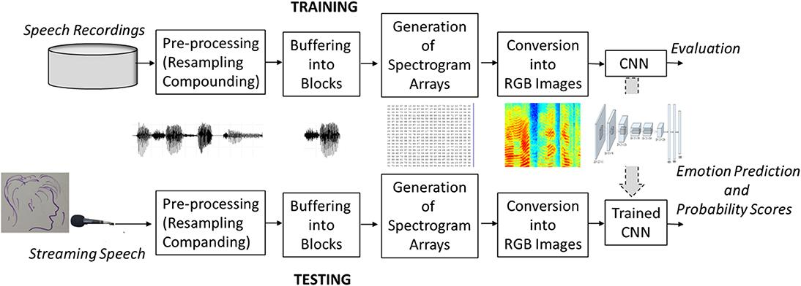

Activity Diagram Explanation
Given that the available computational resources were limited, and only a small database of emotionally labeled speech samples was available, the aim was to determine a computationally efficient approach that could work with a small training data set. These limitations are quite common and can be dealt with by the application of pre-trained networks and transfer learning. Since the majority of existing pre-trained networks have been created for image classification, to apply these networks to speech, the SER problem had to be re-defined as an image classification task. To achieve this, labeled speech samples were buffered into short-time blocks. For each block, a spectral amplitude spectrogram array was calculated, converted into an RGB image format, and passed as an input to the pre-trained CNN.

6.3 Sequence Diagram:
Sequence diagram describes interactions among classes in terms of an exchange of messages over time. Sequence diagrams are popular, dynamic, modeling solutions in UML. They specifically focus on Lifelines or the processes and objects that live simultaneously and the messages exchanged between them to perform a function before the lifeline ends.
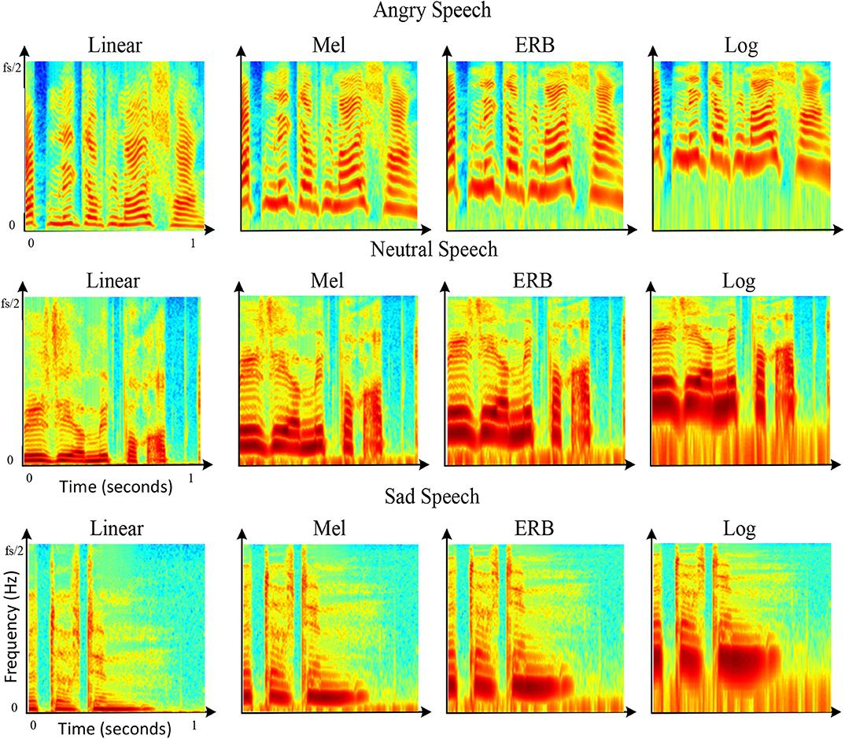

Fig (i): Admin Type Sequence Diagram

6.4 Variation in Energy Across Emotions
To ensure uniformity in our study of energy variation as the audio clips in our dataset were of different lengths, a power which is energy per unit time was found to be a more accurate measure. This metric was plotted with respect to different emotions. From the graph See Fig. 2) it is quite evident that the primary method of expression of anger or fear in people is a higher energy delivery. We also observe that disgust and sadness are closer to neutral with regards to energy although exceptions do exist.
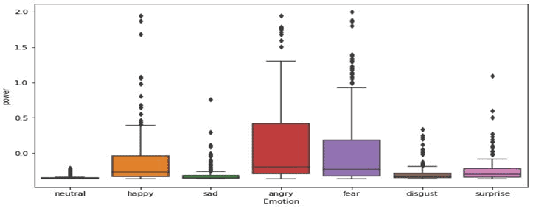

Fig (ii):Variation in Energy Across Emotions

6.5 System Architecture:
A typical speech recognition system is developed with major components that include acoustic front-end, acoustic model, lexicon, language model and decoder as shown in figure 1. Acoustic front-end takes care of converting the speech signal into appropriate features which provides useful information for recognition. The input audio waveform from a microphone is converted into a sequence of fixed -size acoustic vectors is a process called feature extraction. The parameters of word / phone models are estimated from the acoustic vectors of training data. The decoder International Journal of Signal Processing, Image Processing and Pattern Recognition operates by searching through all possible word sequences to find the sequence of words that is most likely to generate The functionality of automatic speech recognition system can be described as an extraction of a number of speech parameters from the acoustic speech signal for each word or sub-word unit. The speech parameters describe the word or sub-word by their variation over time and together they build up a pattern that characterizes the word or sub-word. In a training phase the operator will read all the words of the vocabulary of the current application. The word patterns are stored and later when a word is to be recognized its pattern is compared to the stored patterns and the word that gives the best match is selected. This technique is generally referred to as pattern recognition

6.6 Compression or Expansion System
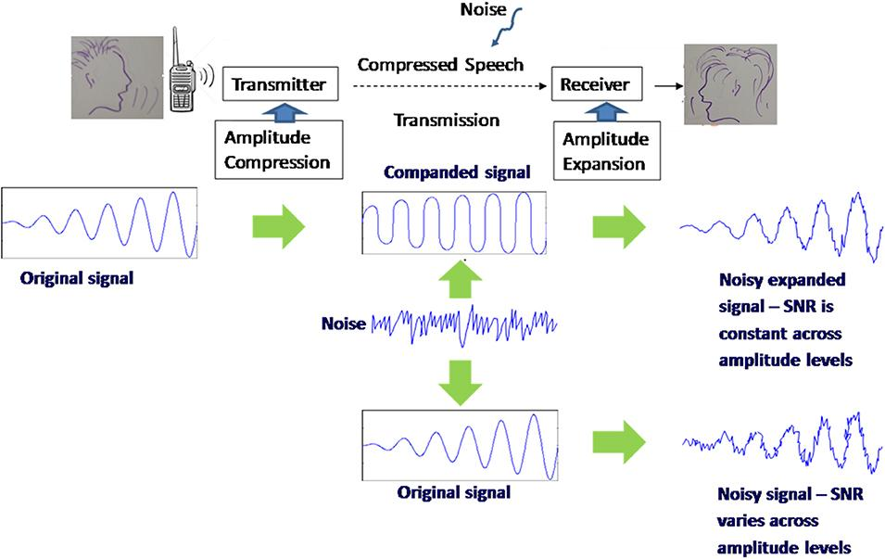

Fig (iii): The compression/expansion (companding) system.

The algorithm applies a logarithmic amplitude compression that gives higher compression to high-amplitude speech components and lower compression to low-amplitude components. The compressed speech is then transmitted through the communication channel, and during the transmission process, it acquires noise. The receiver-end expands the speech signal back to its original amplitude levels while maintaining the same signal-to-noise ratio (SNR) for both high and low amplitude components. A transmission conducted without the companding system would result in high SNR values for high amplitude signal components and low values for low-amplitude

7. SYSTEM DESIGN AND IMPLEMENTATION
7.1 System Implementation:

#You’ll need to install the following libraries with pip:
pip install librosa soundfile numpy sklearn pyaudio

#Make the necessary imports before coding:

import librosa
import soundfile
import os, glob, pickle
import numpy as np
from sklearn.model_selection import train_test_split
from sklearn.neural_network import MLPClassifier
from sklearn.metrics import accuracy_score

#Define a function extract_feature to extract the mfcc, chroma, and mel features from a sound file. This function takes 4 parameters- the file name and three Boolean parameters for the three features:

#Data - Extract features (mfcc, chroma, mel) from a sound file

def extract_feature(file_name, mfcc, chroma, mel):
with soundfile.SoundFile(file_name) as sound_file:
X = sound_file.read(dtype="float32")
sample_rate=sound_file.samplerate
if chroma:
stft=np.abs(librosa.stft(X))
result=np.array([])
if mfcc:
mfccs=np.mean(librosa.feature.mfcc(y=X, sr=sample_rate, n_mfcc=40).T, axis=0)
result=np.hstack((result, mfccs))
if chroma:
chroma=np.mean(librosa.feature.chroma_stft(S=stft, sr=sample_rate).T,axis=0)
result=np.hstack((result, chroma))
if mel:
mel=np.mean(librosa.feature.melspectrogram(X, sr=sample_rate).T,axis=0)
result=np.hstack((result, mel))
return result

#Data - Emotions in the RAVDESS dataset

emotions={
'01':'neutral',
'02':'calm',
'03':'happy',
'04':'sad',
'05':'angry',
'06':'fearful',
'07':'disgust',
'08':'surprised'
}

#Data - Emotions to observe

observed_emotions=['calm', 'happy', 'fearful', 'disgust']
#Now, let’s load the data with a function load_data() – this takes in the relative size of the test set as a parameter. x and y are empty lists; we’ll use the glob() function from the glob module to get all the pathnames for the sound files in our dataset. The pattern we use for this is: “D:\\DataFlair\\speech data\\Actor_*\\*.wav”. This is because our dataset looks like this:

#Data - Load the data and extract features for each sound file

def load_data(test_size=0.2):
x,y=[],[]
for file in glob.glob("D:\\DataFlair\\ravdess data\\Actor_*\\*.wav"):
file_name=os.path.basename(file)
emotion=emotions[file_name.split("-")[2]]
if emotion not in observed_emotions:
continue
feature=extract_feature(file, mfcc=True, chroma=True, mel=True)
x.append(feature)
y.append(emotion)
return train_test_split(np.array(x), y, test_size=test_size, random_state=9)

#Time to split the dataset into training and testing sets! Let’s keep the test set 25% of everything and use the load_data function for this.

#Data - Split the dataset
x_train,x_test,y_train,y_test=load_data(test_size=0.25)

#Data - Get the shape of the training and testing datasets
print((x_train.shape[0], x_test.shape[0]))

#Data - Get the number of features extracted
print(f'Features extracted: {x_train.shape[1]}')

#Now, let’s initialize an MLPClassifier. This is a Multi-layer Perceptron Classifier; it optimizes the log-loss function using LBFGS or stochastic gradient descent

#Data - Initialize the Multi Layer Perceptron Classifier

model=MLPClassifier(alpha=0.01, batch_size=256, epsilon=1e-08, hidden_layer_sizes=(300,), learning_rate='adaptive', max_iter=500)

#Data - Train the model

model.fit(x_train,y_train)

#Data - Predict for the test set

y_pred=model.predict(x_test)

#Data - Calculate the accuracy of our model

accuracy=accuracy_score(y_true=y_test, y_pred=y_pred)

#Data - Print the accuracy

print("Accuracy: {:.2f}%".format(accuracy*100))

#below code for Text to Speech

import speech_recognition as sr
r = sr.Recognizer()
with sr.Microphone() as source:
print("Speak Anything :")
audio = r.record(source, duration=4)
print("Recognizing....")
text = r.recognize_google(audio)
print(text)

7.2 Sampling Frequency

In traditional narrow-band data transmission systems, the bandwidth of speech signals was limited to reduce the transmission bit rates. In telephony, for example, the frequency range of speech used to be limited to the range from 300 Hz to 3.4 kHz. It was enough to ensure a basic level of speech intelligibility but at the cost of high voice quality. It was likely that such severe bandwidth reduction resulted in a substantial reduction in the emotional information conveyed by speakers.
To test this possibility, the SER system was trained with two different sampling frequencies, the original 16 kHz corresponding to the broad speech bandwidth of 8 kHz, and the reduced sampling frequency of 8 kHz corresponding to the narrow-bandwidth of 4 kHz.
The procedure used to reduce the sampling frequency from 16 to 8 kHz consisted of two steps (Weinstein, 1979). Firstly, an 8th order lowpass Chebyshev Type I infinite impulse response filer was applied to remove frequencies beyond the Nyquist frequency of 8 kHz to prevent aliasing. Secondly, the speech was downsampled by a factor of 2 by removing every second sample.

8. RESULTS & OUTPUTS

8.1 Results:

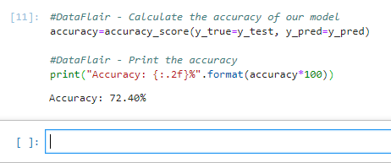
Fig (iv): Results system

8.2 Average Accuracy:

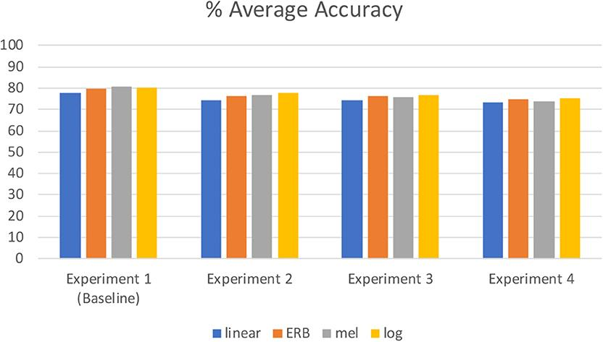

Fig (v): Average Accuracy:

8.2 Overall Efficiency

The experiment was conducted for 100 trials and the overall efficiency was found to be 89% which proved to be higher than the individual algorithms’ eciencies as shown in Table 2 and Figure 9. Also the overall efficiency achieved using the fused algorithms (MFCC,) is higher than those obtained on the same data set 13,14. It shows that the eciency settles down to a constant over 100 trials.

CONCLUSION

The recent interest in speech emotion recognition research has seen applications in call center analytics, human machine and human robot interfaces, multimedia retrieval, surveillance tasks, behavioral health informatics, and improved speech recognition. In this study, the overview of SER methods are discussed for extracting audio features from speech samples, and various classifier algorithms are explained briefly. Speech Emotion Recognition has a promising future and its accuracy depends upon the emotional speech database ,combination of features extracted from those databases for training the model, types of classification algorithm used to classify the emotions in appropriate emotion class (e.g. happy, sad, anger, surprise etc.). This study aims to provide a simple guide to the beginner who’s carried out their research in speech emotion recognition.
Speech is the most natural and environment friendly way of verbal exchange between humans. Lots of efforts have been made to boost a human computer interface so that one can easily have interaction and talk in an unskilled way. Emotion recognition from speech statistics can make the machine extra human-like and it can resource the robot to respond according to the tone and sentiments of the user’s voice.
Through this mini project, we showed how we can leverage Machine learning to obtain the underlying emotion from speech audio data and some insights on the human expression of emotion through voice. This system can be employed in a variety of setups like Call Centre for complaints or marketing, in voice-based virtual assistants or chatbots, in linguistic research, etc.

REFERENCE

- Sonal Kasliwal, Sushma Kotkar and H.D.Gadade (2016),Employee Tracking and Monitoring System Using Android International Journal of Innovative Research in Advanced Engineering (IJIRAE) SSN: 2349-2763, Issue 03, Volume 3, page 1-4
- Priti P. Dafale, Nilima N. Mandal and Divyamala B. Thakare (2015), monitoring employee’s smartphone using android application, Proceedings of 20th IRF International Conference, Chennai, India, ISBN: 978-93-84209-01-8
- Aparna Chandran (2013), Smartphone Monitoring System, International Journal of Computer Science & Engineering Technology (IJCSET) ISSN : 2229-3345 Vol. 4 No. 04, page 451-452
- Shermin Sultana1, Asma Enayet1 and Ishrat Jahan Mouri (2015), A Smart, Location Based Time And Attendance Tracking System Using Android Application International Journal Of Computer Science, Engineering And Information Technology (Ijcseit), Vol. 5,No.1,
- M.D. Nirmal, Rohit Koul, Halne Atul, Gagare Tejaswita and Kharde Mayura (2016), Employee Surveillance System Using Android Smart Phone, IJARIIE-ISSN(O)-2395-4396 , Vol-2 Issue-2
- Ashwini Jaybhaye, Prajakta Kokare, Bhakti Toradmal and Tanmay Kulkarni (2015), Employee Monitoring System Using Android Smartphone, International Engineering Research Journal (IERJ) Volume 1 Issue 2 Page 32-35, ISSN 2395-1621

Literature References
• Ittichai Charoen, C. (2012). Speech recognition using MFCC. … Conference on Computer …, 135–138. https://doi.org/10.13140/RG.2.1.2598.3208
• Al-Talabani, A., Sellahewa, H., & Jassim, S. A. (2015). Emotion recognition from speech: tools and challenges. Mobile Multimedia/Image Processing, Security, and Applications 2015, 9497(May 2020), 94970N. https://doi.org/10.1117/12.2191623
• Sezgin, M. C., Gunsel, B., & Kurt, G. K. (2012). Perceptual audio features for emotion detection. EURASIP Journal on Audio, Speech, and Music Processing, 2012(1), 16. https://doi.org/10.1186/1687-4722-2012-16

Dataset References:
SAVEE: http://kahlan.eps.surrey.ac.uk/savee/Download.html
TESS: https://tspace.library.utoronto.ca/handle/1807/24487
RAVDESS: https://zenodo.org/record/1188976#.XvbvZudS_IU
BERLIN: http://www.emodb.bilderbar.info/download/
CREMA-D: https://github.com/CheyneyComputerScience/CREMA-D

